**Pyber Analysis Results**

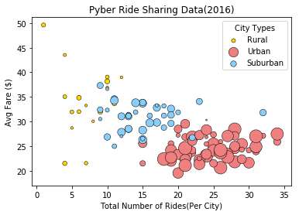

1.Total Rides do not have influence on the Average Fare. As the number of rides increases, the average fare remains at the same level especially in Urban cities where the Average Fare is consistently within $20-$30 range.

2. The Number of Drivers do not have influence on the Average Fare. Average Fare are spread within the $20-$30 range irrespective of the Number of Drivers

3. Ride sharing in Urban cities take the highest market share across the three metrics (Total Fare, Total rides, and Total Driver).

